

**Cloud Deployment Models**

**Name:** Pratham Kandari

**Sap Id:** 500097663

**Batch:** 7

**LAB 8**

**Openstack CLI & RC File Configuration**

Step 1: Open the openstack dashboard and goto API Access

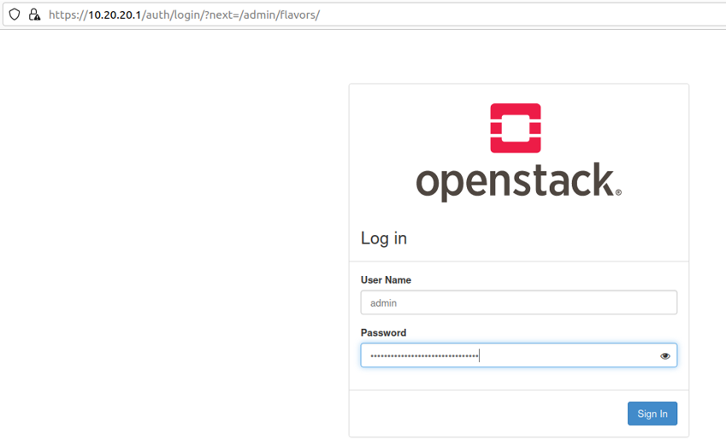

Step 2: Click on download openstack rc file

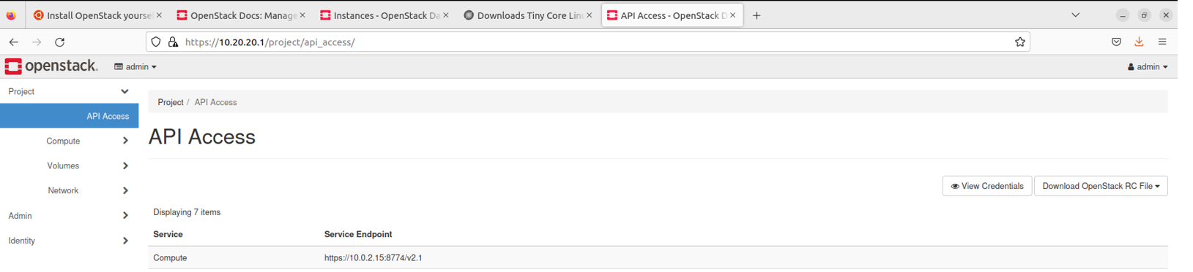

Step 3: Use the command on the linux terminal to install pip

sudo apt install python-dev python-pip

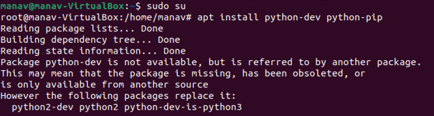

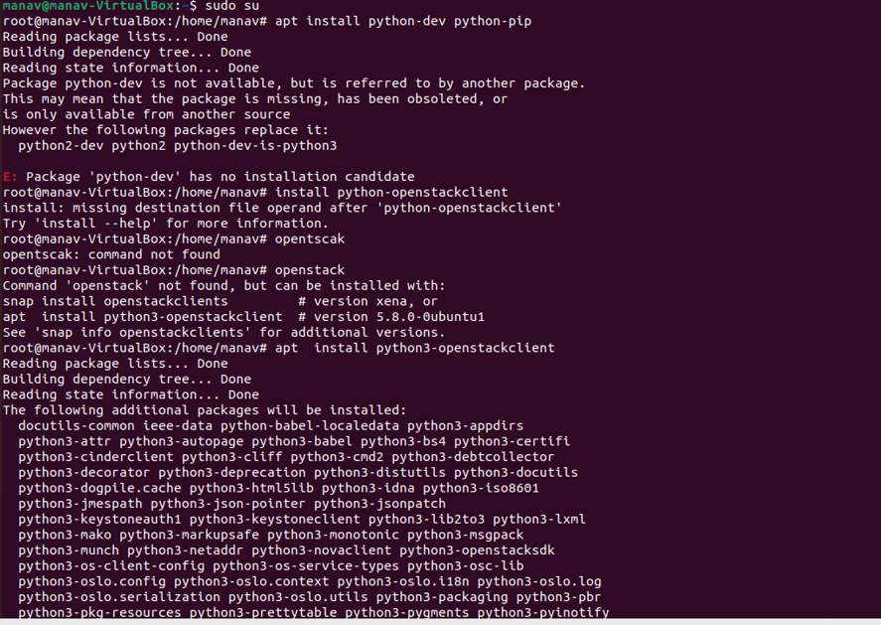

Step 4:- Use the command to install openstack cli

sudo apt install python3-openstackclient

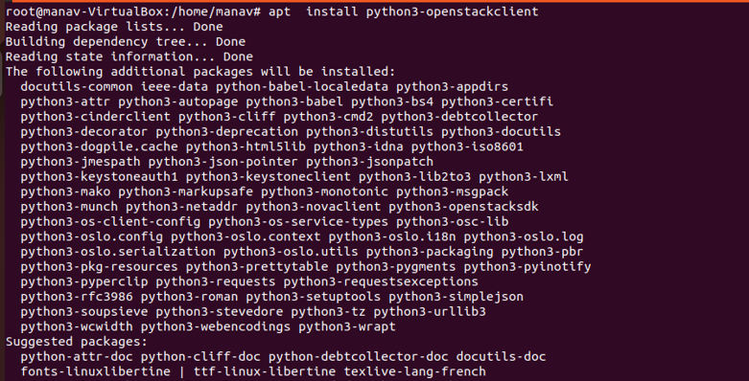

Step 5:- Use the command to enter downloads directory

cd Downloads

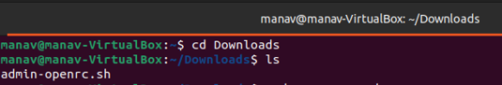

Step 6:- Use the command to edit the admin-openrc.sh file (remove OS_CACRET)

nano admin-openrc.sh



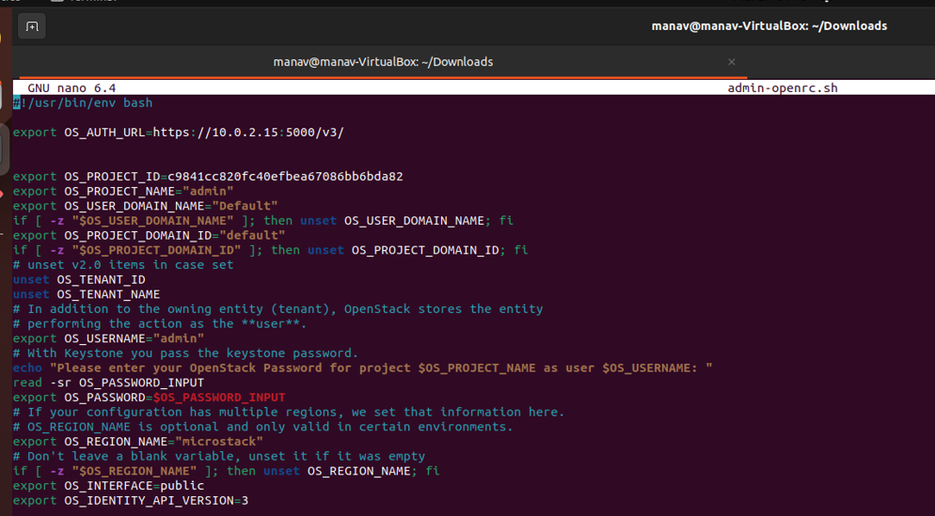

Step 7:- Use openstack cli commands like

openstack -–insecure server list

openstack -–insecure image list

The --insecure option tells the CLI to ignore SSL certificate verification.

